Notice of Completion – Phases 1 & 2
Fenelon Falls Second Crossing Municipal Class Environmental Assessment Phases 1 & 2 Completion

The City of Kawartha Lakes, with support from Dillon Consulting, has completed Phases 1 and 2 of the Municipal Class Environmental Assessment (EA) process for the Fenelon Falls Second Crossing. Phases 1 and 2 were completed following the requirements for and in accordance with Schedule B projects under the Municipal Class EA process. During the study, changes to EA requirements reclassified the potential undertaking from a Schedule B to a Schedule C project. As such, additional EA work is required in the future to complete Phases 3 and 4 of the Municipal Class EA process.

Project Background
The primary objective of this Municipal Class EA was to identify a transportation solution to address existing and future traffic congestion in the town of Fenelon Falls. The study was informed by the City’s Transportation Master Plan and the Fenelon Falls Corridor Study which identified the need for additional roadway capacity across the Trent-Severn Waterway as a way to reduce vehicle delays in the corridor during peak traffic demand times. The identification and assessment of potential solutions to address traffic issues in Fenelon Falls followed Phases 1 and 2 of the Class EA process. Solutions studied included expanding the existing bridge in Fenelon Falls, adding a new second bridge crossing in town, constructing a bypass around town, or completing traffic operations improvements at existing intersections in order to improve traffic flow. Recommendations based on the work completed for Phases 1 and 2 included further study of the bypass solution as a future potential undertaking. The bypass solution would require a new bridge over the Burnt River at 3rd Concession Road, connecting Highway 35 to County Road 121.

More information on the study, including presentations and reports to Council can be accessed online at https://jumpinkawarthalakes.ca/ffsecondcrossing. Given that more EA work is required for Phases 3 and 4 of the EA process, there is no formal 60 review period or EA approval process for the study at this time. Persons interested in future phases of work may provide written comments or questions to the following contact person at the City:

City of Kawartha Lakes
Corby Purdy, Supervisor, Infrastructure Design and Construction
Email: cpurdy@kawarthalakes.ca

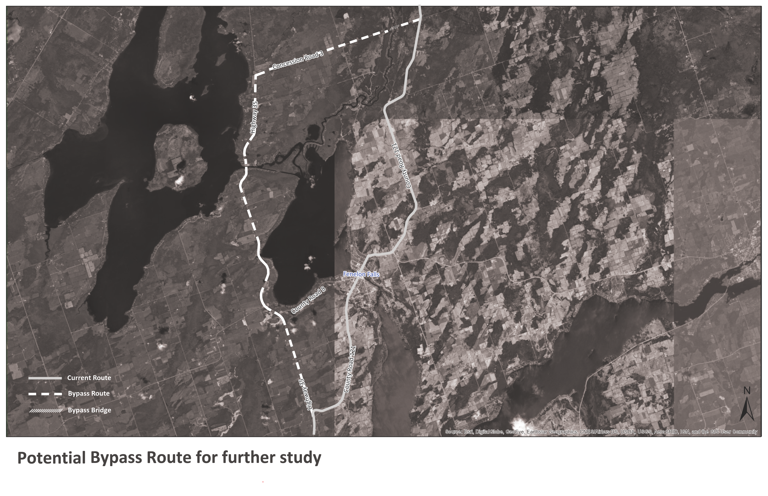
Issue Date: April 14, 2022

